# Lab 1: Setting Up Azure IoT Hub

In this lab you will provision an Azure IoT Hub and an IoT Hub device.

In this lab the following actions will be performed:

* Create Azure Resource Group
* Setup an Azure IoT Hub
* Cleanup

## What you will need:

* Microsoft Azure Account

## Create Azure Resource Group

In this step an Azure Resource Group will be created. An Azure Resource group can be used as a container to group resources.

“A resource group is a container that holds related resources for an application. The resource group could include all of the resources for an application, or only those resources that are logically grouped together. You can decide how you want to allocate resources to resource groups based on what makes the most sense for your organization.”

1. Navigate to the Azure Portal (<https:///portal.azure.com>).
2. Click on: Resource groups
3. In the resource groups blade click on “Add”

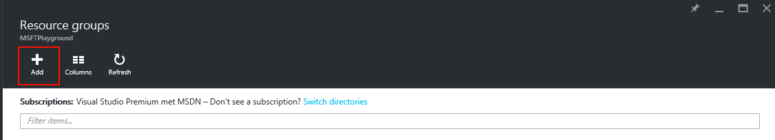

1. In the blade that appears fill in the right information and select your default location:

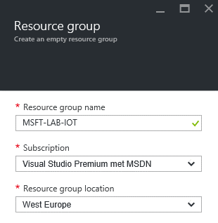

1. Click on “Create” to create the resource group.

## Setup an Azure IoT Hub

In this step an Azure IoT Hub will be created.

1. Open the Azure Portal (<https://portal.azure.com>)
2. Click on: Resource groups > Your Resource group.
3. In the blade of your resource group click on “Add”

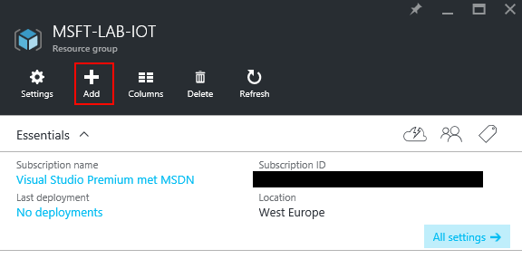

1. In the blade that appears search for “IoT Hub” and click on the first result.
2. A new blade appears in this blade click on “Create”.

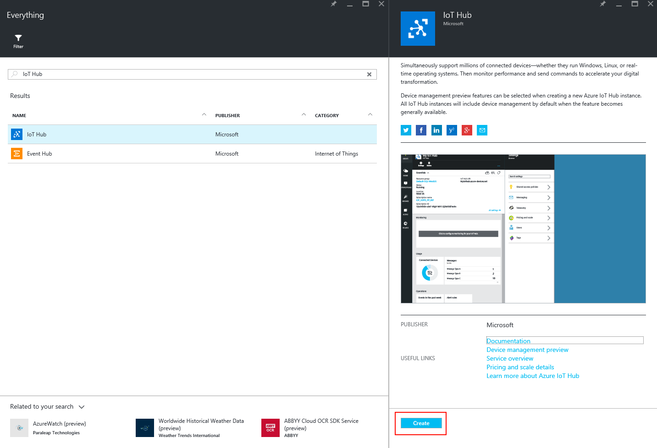

1. Again a new blade will be opened. In this blade you have to enter the properties of your IoT Hub.

|  |  |  |
| --- | --- | --- |
| Property | Description | Information |
| Name | The name of the IoT hub | You can pick any name you want. It will be validated when entering the text. |
| Pricing and Scale tier | The pricing tier for the IoT hub. | Select the F1 – Free pricing tier. For this lab that’s enough. |
| IoT Hub units | An IoT hub unit includes a certain number of messages per day, so choosing the number of IoT units means that the total number of messages supported for this hub is the number of units multiplied by the number of messages per day for that tier. For example, if you want the IoT hub to support ingress of 700,000 messages, you choose 2 units of the S1 tier. | 1 is the default value for the F1 pricing tier |
| Device-to-cloud partitions | You can change the number of partitions for an IoT hub. Default partitions are set to 4; however, you can choose a different number of partitions from a drop-down list. | Two partitions is the default value for the F1 pricing tier. |
| Resource group | The container where in you want to create the IoT hub | Use “Use existing” to create it in the resource group created in the previous step. |
| Subscription | The Azure subscription where in the IoT hub needs to be created | By default you only have one subscription. If you have multiple subscriptions select the correct one. |
| Enable Device Management – PREVIEW | A preview feature for showing the devices added to the IoT hub. | Select this option if you want to make use of this feature. When selected you cannot create the IoT hub in West Europe |
| Location | The location to provision the IoT hub in. | By default use West Europe. If you have selected the “preview” feature choose your own location for example “North-Europe”. |

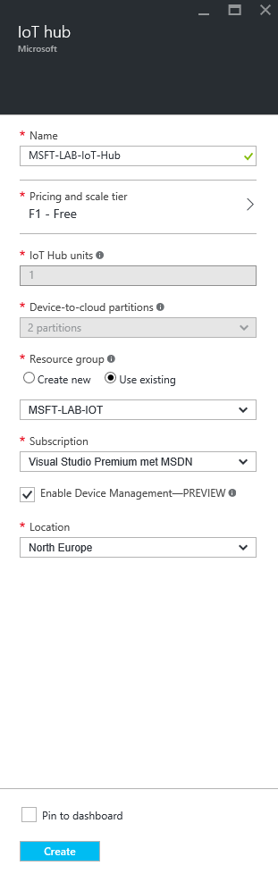

Once the IoT Hub is created, navigate into it to retrieve the connection strings to connect your devices:

1. Click on: Resource groups > Your Resource group > IoT Hub Name
2. In the IoT Hub blade click on the key icon on the top.
3. Select the: iothubowner policy and copy the connection string with the primary key.

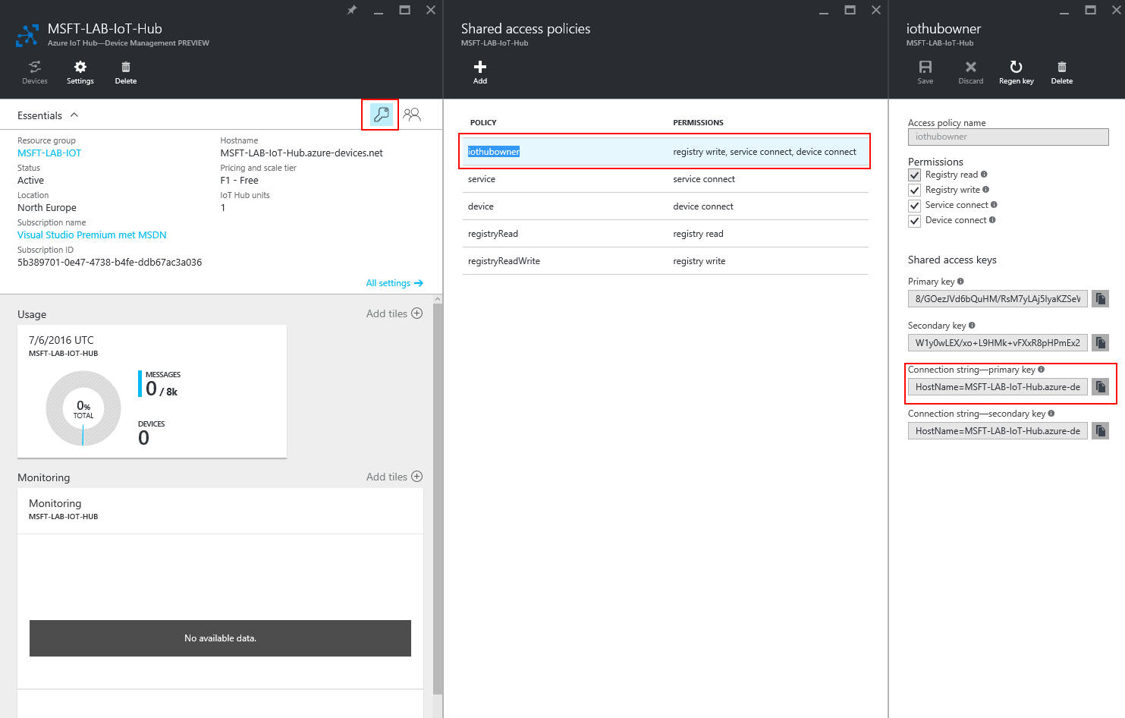

## Cleanup.

The following actions will delete all resources created within this Lab, if you want to keep the resources you can skip this step.

1. Navigate to the Azure Portal (<https://portal.azure.com>).
2. Click on: Resource group > Your Resource Group you created for this Lab
3. In the top bar click on: “Delete”.